939594940

https://www.epet-info.com/dlgcjsen/issue/browser

Click here to go to the current issue

You will get current issue page like below.

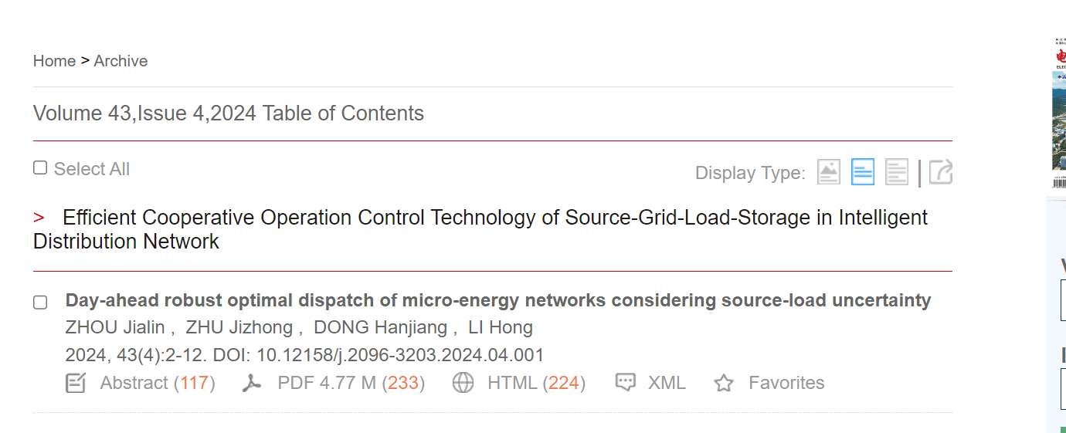

Click here to download pdf

Page range

Year

Volume

DOI

Article title

Issue

Need both non roman and English tocs